# Abstract

In the Internet of things (IoT), data gathered from a global-scale deployment of smart-things are the base for making intelligent decisions and providing services. This paper focuses on the IoT data from a Wind Site with many Wind Turbines and aims to implement a method for detecting and tracking data quality (DQ) of the IoT data. The paper aims to identify the definitions of the DQ dimensions specific to the domain for Wind Sites. After generating a method to detect data quality a dataset from a live wind site is used to determine the effectiveness of the DQ strategy. Data capture settings are adjusted to understand the tradeoffs between DQ dimensions. Data is also categorized and analyzed in batches to understand the DQ of the captured dataset. The results explore any improvements or actionable information that can be used to improve the DQ. In conclusion the possibility of future research and enhancements is presented.

## Keywords:

Wind farms, SCADA data, Pre-processing, Outliers , Fault diagnosis, Renewable energy, IoT, IIoT, Data Quality, Smart Grid, Wind Turbines, Cloud, Statistical Detection, Machine Learning, Infrastructure

# Introduction

Wind power is the most growing renewable source (Appavou et al. (2016)), however the operation and maintenance of the wind turbines account for 25%–35% of the generation costs (Milborrow (2003)). In order to increase the economic competitiveness with respect to fossil fuels and accelerate the transition towards ecologically sustainable systems, there is a need for a more efficient management and this requires better monitoring of wind turbines. Modern wind turbines record more than 1000 variables at intervals of 50ms to 10 mins by means of their SCADA (Supervisory Control and Data Acquisition) system.

The SCADA system collects data from different parts of the turbine, which are grouped into systems (Vestas R+D (2004)) and providing information about: temperatures, electrical indicators, physical posi- tions, speeds, vibration, etc. These systems generate a huge amount of data (Voev and Siemens, 2014), which has to be preprocessed and modeled in a feasible time (Justin Heinermann (2015)). Due to this, cloud-based platform services seem to be a better option to process SCADA data taking into account its processing scalability (Rodero- Merino (2011)) and high availability to build prediction engines for early diagnosis (called prognosis), then improving the efficiency of the wind farms, which translates in the reduction of generation costs (Besnard and B, 2010).

These prognosis systems have to work in a wide set of wind turbines, with different models, manufacturers and SCADA- data configurations. Raw data obtained from SCADA contains several kinds of errors categorized as: missed data caused by communications failures, presence of extreme values due to sensors failures, data coming from poorly calibrated sensors or by replaced sensors which report outputs in a different range, errors in the SCADA system or even human errors (Gray (2011)).

Cloud-based platforms can be heaviliy leveraged to introduce greater statistical methods to improve the data quality of the raw data. The cloud based platforms also provide a new channel to consume modern sensors outside of traditional SCADA systems. The new devices that capture more raw data can help in providing deeper insights on operational technologies at wind farms. The growth of interconnected devices has skyrocketed in the recent years , lending to a surge in data capture and automated action without the need of human intervention. This phenomenon of interconnected devices communicating from machine to machine is called M2M or Internet of Things (IoT).

The Industrial Internet of Things (IIoT) goes beyond the normal consumer devices and internetworking of physical devices usually associated with the IoT. What makes it distinct is the intersection of information technology (IT) and operational technology (OT). OT refers to the networking of operational processes and [industrial control systems](https://www.trendmicro.com/vinfo/us/security/definition/industrial-control-system) (ICSs), including human machine interfaces (HMIs), supervisory control and data acquisition (SCADA) systems, distributed control systems (DCSs), and programmable logic controllers (PLCs). These operational technologies are found in power generation systems such as wind and solar farms.

By integrating IIoT into these power generation systems the operational capabilities increase and drive improved processes that can generate cheaper renewable energy for consumers. Increases in data consumption from real-time sensors can lead to increases in visibility, insights and specific actions that enable the general office to bridge the gap with site operations. In the information age the data driven decisions from the IIoT allow these systems to become automated and more responsive to the needs of each interconnecting “thing”, allowing an ecosystem of devices to operate efficiently.

The paper seeks to provide a design architecture for capturing operational data from a wind site and apply methods to optimize data quality given real world constraints, such as network bandwidth, protocol limitations, connection losses, corrupted data, computational resources, noise, etc.

[TODO]The greatest challenge to IIoT is the optimization of data gathering. The constraints of data collection need to be mitigated. The more data collected the more potential for insights but can become a costly endeavor. By understanding the opposing constraints, a control “cost-to-go” function can be leveraged to optimize data collection properties when using ICS protocols.

# Wind Farm Communication Architecture

The required data to be transmitted from the wind farm to the SCADA system is divided in four categories:

* Substation data (statuses, alarms, meters, etc...)
* Weather towers data
* Turbines data
* Production data.

To achieve these requirements, a wind farm communication system has been proposed as described by Fig. 1. A data concentrator collects the data from multiple sources using TCP/IP or RS232/485 connections. The wind turbines and weather towers are connected to the substation using optic fiber connection. The wind turbines are either connected to a proprietary server which is connected to the data concentrator or directly connected to the substation network. In addition, the data concentrator collects the information of intelligent electrical devices such as meters, protection equipment and power quality modules. The collected data will be subsequently published to different data clients such as distribution grid SCADA, historian servers and local (Human Machine Interface) HMI.

Furthermore, the data described above can be delivered to end users in two different forms: *real time data*, which is basically a simple transmission of the acquired information from all the devices in the substation or computed from this data (for key indicator information as availability turbines counters, availability power at the wind plant, etc.) and *statistical data* which is calculated from real time data and transmitted periodically to SCADA systems [1]. This data is used by the utility to build up an historical database which is used for forecasting and impact analysis purposes [3].

*This paper will focus only on the data collected at the turbine level for simplicity.*

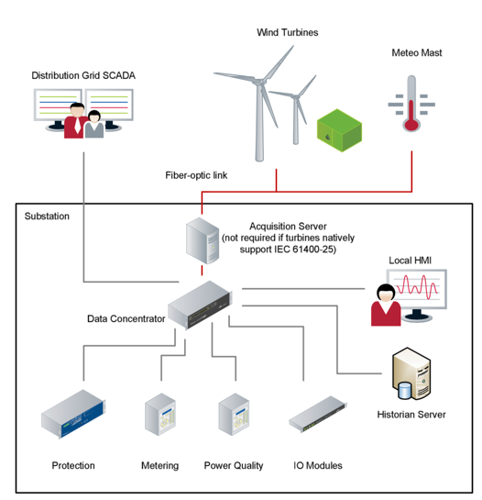

Figure 1 - WindFarm Communication

## IEC 61400-25: A Brief Overview

According to IEC61400-25 User Group [2], the IEC standard series 61400-25 provides a solution for access to wind power plant information with standardized data names and semantic. It gives possibilities to procure monitoring and control solutions as separate parts, and to use a single system to store, analyze and present wind power information. In addition, the standard opens up for control and monitoring of information from different wind turbine vendors in a homogeneous manner.

The approach of the standard is to decompose the application functions into the smallest entities, which are used to exchange information. These entities are called logical node (LN). A LN consists of a gathering of related data defined as Data Classes (DC). All the information in a logical node is contained in the respective DC. The structures of all LN is similar and has a standardized form where different types of LN can be constructed through the combination of different optional DC.[3][4]

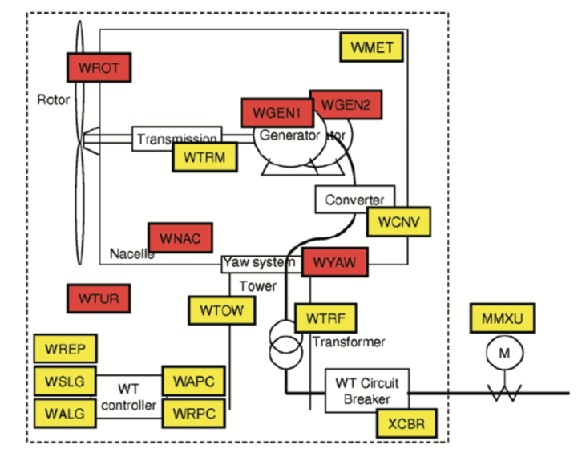

*The problem with standards is that everyone has one. - Anonymous*

### Unused Standard

The GE WindSCADA 10.0 SP2 did not use the IEC standard described for the GE 1.5 ESS wind turbines. The SIEMENS WPS 2.0 SCADA also did not use the IEC standard for its wind turbines. These systems need to have IEC standard mapped to the OEM naming convention in order to support a cohesive standard. SCADA data that follows the IEC 61400–25 format IEC (2006) uses a hierarchical structure of turbines (Logical devices) and physical systems (Logical nodes).

## Data Gathering

The Supervisory Control and Data Acquisition (SCADA) server is a computer system that hosts a software from the wind turbine OEM that polls the data from the turbines and then sends information to the entire wind farm in order to control the overall operation of the site. The SCADA server provides a way for users to extract real-time data from the system in order to analyze and record the data. The protocol used to expose this data can be any of the standard Industrial Control System(ICS) protocols, such as DNP3, OPC, Modbus, etc. The protocol that shall be discussed in this paper is OPC.

Data is gathered via an OPC(OLE for Process Control) (OPC Fundation (2016)) with update periods of 5–10min, producing several types of indicators. Only failure events and statistical indicators are kept. Each sensor usually provides min, mean, max and standard deviation values.

An OPC Connection requires an OPC client such as a free utility called “Matrikon OPC”. This application allows a user to connect to a local or remote OPC server and browse the tags by creating an OPC group with some connection properties. The group allows settings that can effect the collection of the data. Update Rate,Percent Deadband , Async/Sync , Time Bias . By focusing on these group setting changes to the capture of the data can be effected. Intrinsic data quality measurements can suffer if these settings are not tuned properly. The goal is to optimize these settigns in order to maximize the data quality and capture of critical tags.

Collection of the data over OPC is done by subscribing to the “OPC Server”. The OPC Server is typically a windows service that utilizes DCOM communication over port 135 and other ephemeral ports. The OPC server allows any tcp/ip connection using OPC Client software to browse, read, write, or subscribe to “Tags”. Many OPC Servers can exist on the same computer. This means each OPC server needs to have a unique OPC Server Name or “CLSID” associated with the OPC server. These CLSID’s are recorded on the computer’s registry. The OPC Server provides a prebuilt hierarchy of tags very similar to a folder structure. The convention is to address tags using a “.”, between each of the hierarchal branches leaving a tag “name” leaflet as the last item in the branch.



Figure 2- GE WindTurbine SCADA Screen





# Data Quality on Real Wind Farm

Selected wind site has 37 turbines and is a GE wind site. The data for the turbine is a lot on the opc server. More than what we can review. A set of critical tags can be chosen that provide the greatest value to the end user for data analysis. This data will be reviewed for data quality rules and provided to users with the expectation of the data quality dimensions to be meant throughout its lifecycle.

|  |  |  |  |  |  |  |  |  |  |  |
| --- | --- | --- | --- | --- | --- | --- | --- | --- | --- | --- |
| # WTGs | Site MW | Base Rating | Rotor | Blade Types | Pitch Type | Tower Height | Controller | Converter Type | Software Version | SCADA Version |
| 37 | 59.9 | 1.62 | 100 | Glass | Salem | 80 | MarkVI | GE ESS | 44.76.00C | WindSCADA 10.0 SP2 |

Before looking at Data Quality the data should be in a standard such as an IEC standard as described in previous sections. In the proposed wind farm example, the SCADA server provides two OPC Servers. Connecting to either OPC server shows a non standard tag name convention for the data of a single wind turbine. The documentation for the SCADA system only provides detailed descriptions for one of the two connections.



Conversion of non-standard OPC data requires understanding of th e

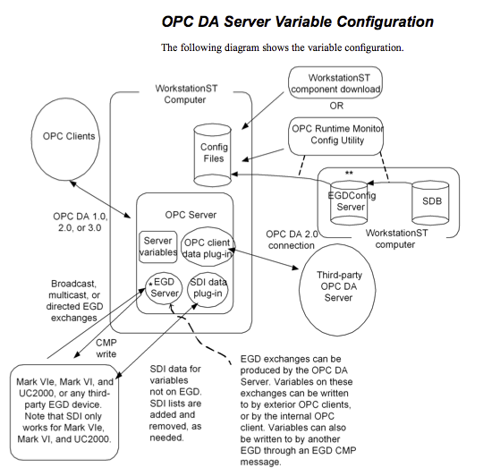



Data items

2.2.2 Items

Items are the representation of data points from the realtime database.

Each item has a value that includes the data, the quality of data and a timestamp.

The data of items are generally transferred in Intel-Format (Little Endian).

There are six kinds of items:

1. Realtime data items

Data comes from systems with a cycle time of one second. Most of these items are defined as float values (4

bytes).

It is recommend to set the scan rate to 1000 msec.

e.g. P_ACT

2. Operational data items

Data comes from systems or calculation engines with a cycle time of 10 minutes. Most of these items are

defined as unsigned long values (4 bytes).

e.g. PROD

3. Digital IO Data items

The digital IO from the systems are organized in unsigned long words (4 bytes).

Each bit from this word stands for one digital input or output signal.

Digital IO comes from systems or calculation engines with a cycle time of one second.

e.g. DI_MAIN

4. Event data items

All events or error signals are organized in unsigned long words ( 4 bytes ).

Each bit from this word stands for one event.

Events come from systems with a cycle time of one second.

e.g. EVENT_001-016

5. Status data items

Status data is digital information about the state of different things within a system.

The states from the systems are organized in unsigned long words (4 bytes).

Each bit from this word stands for one state.

The states come from systems with a cycle time of one second.

e.g. Status_1

6.Command items

The command items (e.g. START and STOP the turbine) write data to realtime database. The realtime

database subscribes the command datapoint for one cycle and gives the data to turbine.

Command Logic: We have two different types of controls. Binary controls (DataType DWORD) and Analog

controls (DataType Single)

Binary Controls: For binary controls only controls with a value 1 are valid controls. A value 0 will not send a

control to the turbine.

Analog Controls: For analog controls a 0 is a valid value. Each OPC Item has a data quality property.

Read back of controls: We cannot deliver a valid state of the control if we read back the control signal. Because

of that we will not allow to read any control via OPC. The AccessRight of a control is Write only

The OPC quality code is made up of 16 bits.

The high 8 bits are avalible for vendor specific use and should be all 0's when not used.

The low 8 bits are broken into three sections.

The first two bits can pass the meaning Good, Bad or Uncertain. If a server does not support quality codes, a good value will always be passed.

The next four bits can be used to provide additional specific information about the general quality.

The last two bits are used if limit information is supported by the server. In VB these are returned as Hex values that can them be converted to meaningful information.

The two most common OPC quality codes are:

192 or hex C0 is good quality.

0 (decimal or hex) is bad quality.

Below is a listing of the OPC specification quality codes:

Hex Value Decimal value OPC Specification Definition

C0 192 Good

D8 216 Good--Local Override, Value Forced

0 0 Bad

4 4 Bad - Configuration Error in Server

8 8 Bad - Not Connected

C 12 Bad - Device Failure

10 16 Bad - Sensor Failure

14 20 Bad - Last Know Value Passed

18 24 Bad - Comm Failure

1C 28 Bad - Item Set InActive

40 64 Uncertain

44 68 Uncertain - Last Usable Value - timeout of some kind

50 80 Uncertain - Sensor not Accurate - outside of limits

54 84 Uncertain - Engineering Units exceeded

58 88 Uncertain - Value from multiple sources -----------with less then required good values

If limit quality is supported then the above numbers mean the value can change

If the value is one greater - value is pegged at Lower Limit

If the value is two greater - value is pegged at High Limit

If the value is three greater - value is constant - can't change

# Intrinsic Data Quality Settings

## Data Quality Accuracy

### Type Range Format

Data type of the signal can effect the quality of the value that is being recorded.

|  |  |  |
| --- | --- | --- |
| Integer | -2147483648..2147483647 | signed 32-bit |
| Real | 1.5 x 10^-45 .. 3.4 x 10^38 | signed 32-bit |
| Double | 5.0 x 10^-324 .. 1.7 x 10^308 | signed 64-bit |
| DWORD | 0..4294967295 | unsigned 32-bit |
| WORD | 0… 65535 | unsigned 16 bit |
| BYTE | 0…255 | unsigned 8 bit |
| BSTR | Pointer to TCHAR array LPCTSTR |  |

### Percent Deadband

The percent Deadband impacts the Data Quality Accuracy Dimensions

The range of the Deadband is from 0.0 to 100.0 Percent. Deadband will only apply to analog items. The EU Low

and EU High values for the item can be used to calculate the range for the item. This range will be multiplied with

the Deadband to generate an exception limit. An exception is determined as follows:

Exception if (absolute value of (last cached value - current value) > (pPercentDeadband/100.0) * (EU High - EU

Low).

The Percent Deadband can be set when AddGroup is called, allowing the same Percent Deadband to be used for

all items within that particular group. However, with OPC DA 3.0, it is allowable to set the Percent Deadband on a

per item basis. This means that each item can potentially override the Percent Deadband set for the group it

resides within If the exception limit is exceeded, then the last cached value is updated with the new value and a notification will

be sent to the client’s call back (if any).

The Percent Deadband is used to keep noisy signals from updating the client unnecessarily.

Standardizing Data from Real Wind Farm

|  |  |  |
| --- | --- | --- |
| GE.WindSCADA.DA | GE.WindSCADA.CSS | IEC 61400-25 |
| Drive_Train_Accel | A_DT |  |
| Tower_Accel | A_TOWER |  |
| Blade_1_Pitch_Angle | BL1_ACT |  |
| Blade_1_Pitch_Angle_Setpoint | BL1_SET_V |  |
| Blade_2_Pitch_Angle | BL2_ACT |  |
| Blade_2_Pitch_Angle_Setpoint | BL2_SET_V |  |
| Blade_3_Pitch_Angle | BL3_ACT |  |
| Blade_3_Pitch_Angle_Setpoint | BL3_SET_V |  |
| Circuit_Breaker_Cut_In_Count | CBCI |  |
| Hydraulic_Unit_Press_1 | HYD_PRES |  |
| L1_Current | I_A |  |
| L2_Current | I_B |  |
| L3_Current | I_C |  |
| Mainshaft_Torque | M_ACT |  |
| Mainshaft_Torque_Setpoint | M_SET |  |
| Gen_RPM_CCU | N_GEN_CCU |  |
| Gen_RPM_PLC | N_GEN_PLC |  |
| Blade_Rotor_Rpm | N_ROT_PLC |  |
| Gen_RPM_Setpoint_1 | N_SET1 |  |
| Gen_RPM_Setpoint_2 | N_SET2 |  |
| Interface_Error_Status | OS |  |
| Op_Status | OS |  |
| Active_Power | P_ACT |  |
| Power_Factor | PF |  |
| Power_Factor_Setpoint | PF_SET_V |  |
| Nacelle_Position | POS_NAC |  |
| Reactive_Power | Q |  |
| Nacelle_Rev | REV_NAC |  |
| State_Fault | STATE_FAULT |  |
| Ambient_Temp_1 | T_AMB |  |
| Pitch_Axis_1_Batt_Box_Temp | T_BAT_BOX_1 |  |
| Pitch_Axis_2_Batt_Box_Temp | T_BAT_BOX_2 |  |
| Pitch_Axis_3_Batt_Box_Temp | T_BAT_BOX_3 |  |
| Gen_Drive_End_Bearing_Temp_1 | T_BEAR_A |  |
| Gen_Non-Drive_End_Bearing_Temp_1 | T_BEAR_B |  |
| Mainshaft_Bearing_Temp | T_BEAR_SHAFT |  |
| Pitch_Center_Control_Box_Temp | T_CTRL_BOX |  |
| Pitch_Axis_1_Control_Box_Temp | T_CTRL_BOX_1 |  |
| Pitch_Axis_2_Control_Box_Temp | T_CTRL_BOX_2 |  |
| Pitch_Axis_3_Control_Box_Temp | T_CTRL_BOX_3 |  |
| Gear_Box_Sump_Temp | T_GEAR |  |
| High_Speed_Bearing_Temp | T_GEAR_BEAR |  |
| Gen_Stator_Temp_1 | T_GEN_1 |  |
| Gen_Stator_Temp_2 | T_GEN_2 |  |
| Gen_Cooling_Air_Temp_1 | T_GEN_COOL |  |
| Hub_Temp | T_HUB |  |
| CTM_Temp | T_MAIN_BOX |  |
| Downtower_Control_Cabinet_Temp | T_MAIN_BOX |  |
| Nacelle_Controller_Temp | T_NAC |  |
| Nacelle_Temp | T_NAC |  |
| Tower_Deflection | TD |  |
| L1_Volt | U_A_N |  |
| L2_Volt | U_B_N |  |
| L3_Volt | U_C_N |  |
| Wind_Speed_1 | V_WIN |  |
| Wind_Dir_10_Sec_SDev | WIND_DEV_10SEC |  |
| Wind_Dir_1_Sec_SDev | WIND_DEV_1SEC |  |

Data Collection to the Cloud

A software application that can collect OPC data in a persistent way is required at the site level in order to push that data to cloud services that can distribute the data into data storage and consumption services. A proposed software model is presented. Highlighting the components needed to configure, subscribe, collect, cache and push to a cloud based service over a IoT standard protocol called MQTT (message queue telemetry transport)

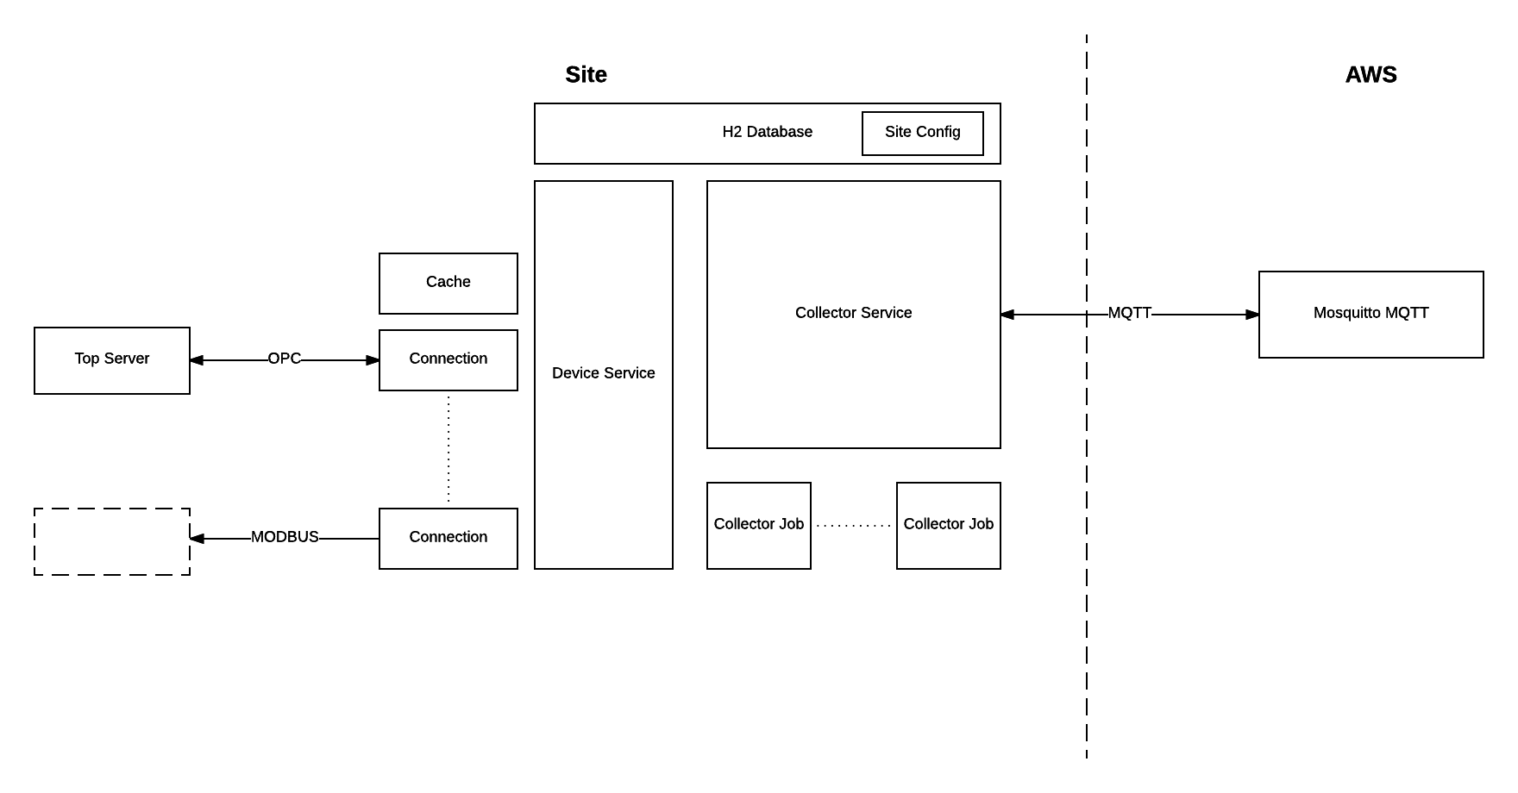

# Data Quality & Dimensionality

## Appendix

Update Rate

Async/Sync

Synchronous Connection

* Client polls server at prescribed refresh rate
* Server sends the tag data whether it has changed or not

Asynchronous Connection

* Server sends the tag data at the prescribed refresh rate
* Server only sends the data if the value has changed
* Async connection uses a new socket. Server initiates a new socket on a negotiated port.

See examples below, treat each tick on the timeline as 1 time unit starting the count at 0. In each example, a synchronous connection set to 1 time unit will receive a tag reading at every point. A synchronous connection set to refresh at 6 time units will receive the first and last values.

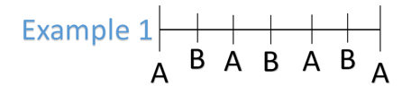

In example 1,  an asynchronous connection set to refresh at 1 time unit, the client receives tag readings at each time unit. An asynchronous connection set to refresh at 6 time units will receive a tag reading of A at time 0. It will not receive a tag reading at time unit 6, because it is the same as the last tag reading.

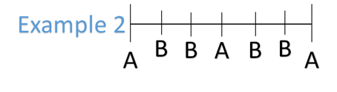

In example 2, an asynchronous connection set to refresh at 1 time unit will receive the following tag reading/time unit pairings: A0, B1, A3, B4, A6. An asynchronous connection set to refresh at 6 time units will receive a tag reading of A at time 0. It will not receive a tag reading at time unit 6, because it is the same as the last tag reading.

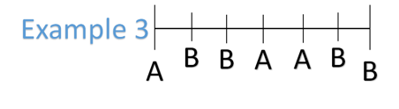

In example 3, an asynchronous connection with a refresh rate of 1 time unit will receive A0, B1, A3, B5. An asynchronous connection set to refresh at 6 time units will receive tag readings of A0, B6.

|  |  |  |  |  |  |  |
| --- | --- | --- | --- | --- | --- | --- |
| ID | Tag | Snap SHOT Minutes over 49 hrs | Average | Max | Min | Standard Deviation |
| 1 | In_WindDirection | 49 | 45.2 | 48 | 33 | 2.4 |
| 1 | AI_CuReacPowerAct | 49 | 46.7 | 48 | 32 | 2.4 |
| 1 | AI_In_GridMonRealPowerAct | 49 | 46.7 | 48 | 33 | 2.4 |
| 1 | In_WindSpd | 49 | 45.2 | 48 | 32 | 2.6 |
| 1 | AI_In_GridMonAppPowerAct | 49 | 46.7 | 48 | 33 | 2.3 |
| 1 | In_RotorSpd | 40 | 44.65 | 48 | 4 | 8.2 |
| 1 | AI_In_GridMonReacPowerAct | 49 | 46.7 | 48 | 33 | 2.3 |
| 1 | AI_In_GridMonCosPhiAct | 49 | 46.6 | 48 | 32 | 2.4 |
| 1 | OpCtl_PowerSetpt | 14 | 41.9 | 48 | 1 | 13.1 |

|  |  |  |  |  |  |  |
| --- | --- | --- | --- | --- | --- | --- |
| ID | Tag | Consistency | Resolution | RSD | Resolution with Error | Resolution With Consistency |
| 1 | In_WindDirection | 100% | 75% | 5% | 73% | 73% |
| 1 | AI_CuReacPowerAct | 100% | 78% | 5% | 75% | 75% |
| 1 | AI_In_GridMonRealPowerAct | 100% | 78% | 5% | 75% | 75% |
| 1 | In_WindSpd | 100% | 75% | 6% | 72% | 72% |
| 1 | AI_In_GridMonAppPowerAct | 100% | 78% | 5% | 75% | 75% |
| 1 | In_RotorSpd | 82% | 74% | 19% | 65% | 53% |
| 1 | AI_In_GridMonReacPowerAct | 100% | 78% | 5% | 75% | 75% |
| 1 | AI_In_GridMonCosPhiAct | 100% | 78% | 5% | 75% | 75% |
| 1 | OpCtl_PowerSetpt | 29% | 70% | 31% | 54% | 16% |

Out of all the tags available on the OPC server the

IEC Convention

Turbine tags can be categorized into IEC standard categories. This categorization will help in identifying the characteristics to present

[International standard](https://en.wikipedia.org/wiki/International_standard) [**IEC**](https://en.wikipedia.org/wiki/International_Electrotechnical_Commission)**61400-25** (Communications for monitoring and control of wind power plants, TC 88) provides uniform information exchange for monitoring and control of wind power plants. This addresses the issue of proprietary communication systems utilizing a wide variety of protocols, labels, semantics, etc., thus enabling one to exchange information with different wind power plants independently of a vendor. It is a subset of [IEC 61400](https://en.wikipedia.org/wiki/IEC_61400); a set of standards for designing wind turbines.[[1]](https://en.wikipedia.org/wiki/IEC_61400-25#cite_note-1)

The IEC 61400-25 standard is a basis for simplifying the roles that the [wind turbine](https://en.wikipedia.org/wiki/Wind_turbine) and [SCADA](https://en.wikipedia.org/wiki/SCADA) systems have to play. The crucial part of the [wind power plant](https://en.wikipedia.org/wiki/Wind_power_plant) information, information exchange methods, and communication stacks are standardized. They build a basis to which procurement specifications and contracts could easily refer.

The standard has specified five mapping (IEC 61400-25-4) to communication protocol stacks in order to address the real wind power business needs for communication. The mappings specified in the part of IEC 61400-25 comprises a mapping to [SOAP](https://en.wikipedia.org/wiki/SOAP)-based [web services](https://en.wikipedia.org/wiki/Web_service), [OPC](https://en.wikipedia.org/wiki/OLE_for_process_control)/[XML](https://en.wikipedia.org/wiki/XML)-[DA](https://en.wikipedia.org/wiki/OPC_Data_Access), [IEC 61850](https://en.wikipedia.org/wiki/IEC_61850)-8-1 [MMS](https://en.wikipedia.org/wiki/Manufacturing_Message_Specification), [IEC 60870-5](https://en.wikipedia.org/wiki/IEC_60870-5)-104 and a mapping to [DNP3](https://en.wikipedia.org/wiki/DNP3).

## Architecture

The architecture of the IIoT will leverage the elastic computing of a cloud infrastructure. Using Amazon Web Services (AWS) to host virtual machines in the cloud a series of

Collecting

Data Encoding & Transmission

* Binary serialization techniques
* How to quantify the quality effects of serialization?
* Time delay in deserialization
* Benchmarking time delay across serialization formats



### Serializers (no shared refs)

Benchmarks serializers

* + Only cycle free tree structures. An object referenced twice will be serialized twice.
  + no manual optimizations.
  + schema is known in advance (pre registration or even class generation). (Not all might make use of that)

Ser Time+Deser Time (ns)  
  
  
Size, Compressed size [light] in bytes

create ser deser total size +dfl

colfer 57 275 527 802 241 152

protostuff 77 449 771 1221 242 153

kryo-flat-pre 65 592 719 1310 216 136

minified-json/dsl-platform 54 527 854 1381 356 206

fst-flat-pre 70 602 946 1548 254 168

protobuf 306 1050 523 1573 242 152

json/dsl-platform 56 602 1033 1635 488 271

msgpack/databind 62 898 1222 2119 236 150

smile/jackson+afterburner/databind 63 965 1264 2229 355 259

cbor/jackson+afterburner/databind 59 938 1305 2244 400 253

cbor-col/jackson/databind 76 965 1390 2355 254 168

thrift-compact 96 1433 928 2362 243 152

json-col/jackson/databind 62 1004 1409 2413 296 187

smile-col/jackson/databind 68 1073 1370 2443 255 168

thrift 92 1630 882 2512 352 201

json-array/fastjson/databind 61 1612 949 2561 284 171

json/fastjson/databind 64 1266 1396 2663 489 271

json/jackson+afterburner/databind 62 1114 1571 2684 488 271

flatbuffers 65 1995 1091 3086 432 231

smile/jackson/databind 72 1429 1690 3119 341 248

json/protostuff-runtime 63 1459 1721 3180 472 252

scala/sbinary 565 1816 1369 3184 258 151

cbor/jackson/databind 61 1464 1822 3286 400 253

json/jackson/databind 65 1322 2016 3338 488 271

capnproto 72 2250 1181 3431 400 210

json/jackson-jr/databind 62 1458 2017 3474 471 263

xml/jackson/databind 60 2718 4653 7371 686 296

json/gson/databind 62 4659 4658 9317 489 268

bson/jackson/databind 72 5317 6766 12082 509 294

xml/xstream+c 61 5122 11471 16593 490 253

json/javax-tree/glassfish 1486 8128 12175 20303 488 273

xml/exi-manual 61 11942 10771 22713 340 331

java-built-in 71 5661 31631 37293 892 520

scala/java-built-in 574 10301 46050 56351 1296 702

json/protobuf 294 7221 51527 58748 500 262

json/json-lib/databind 60 26465 74308 100773 488 273

### Cross Lang Binary Serializers

Contains serializer(-configurations)

* + Only cycle free tree structures. An object referenced twice will be serialized twice.
  + schema is known in advance (pre registration, intermediate message description languages, class generation).

Ser Time+Deser Time (ns)  
  
  
Size, Compressed size [light] in bytes

create ser deser total size +dfl

colfer 57 275 527 802 241 152

protobuf/protostuff 75 481 779 1260 242 152

protobuf/protostuff-runtime 63 553 812 1365 244 153

protobuf 306 1050 523 1573 242 152

msgpack/databind 62 898 1222 2119 236 150

thrift-compact 96 1433 928 2362 243 152

thrift 92 1630 882 2512 352 201

flatbuffers 65 1995 1091 3086 432 231

cbor/jackson/databind 61 1464 1822 3286 400 253

capnproto 72 2250 1181 3431 400 210

hessian 69 4058 5586 9644 504 319

bson/jackson/databind 72 5317 6766 12082 509 294

Cost of features

shows performance vs convenience of manually-selected libs.

* + cycle free, schema known at compile time, manual optimization: kryo-manual, msgpack/manual
  + cycle free, schema known at compile time: protostuff, fst-flat-pre, kryo-flat-pre. (note: protostuff uses class generation while the other two just require a list of classes to be written)
  + cycle free, schema UNKNOWN at compile time: fst-flat, kryo-flat, protostuff-runtime, msgpack/databind
  + full object graph awareness, schema UNKNOWN at compile time: fst, kryo.

Ser Time+Deser Time (ns)  
  
  
Size, Compressed size [light] in bytes

### Full data

create ser deser total size +dfl

colfer 57 275 527 802 241 152

protobuf 306 1050 523 1573 242 152

java-manual 68 801 779 1580 258 151

thrift 92 1630 882 2512 352 201

java-built-in-serializer 68 5917 29560 35476 892 520

java-built-in 71 5661 31631 37293 892 520

__________________________________________________________________________________________________

Colfer is a clear winner for generic text (ascii) data and avro is not compared in this. For avro,

Gathering

Storing

Delivery

Consumption

Groupings of tag by turbine?

WAD1.

Calculations over a given time frame – Data Consistency

Classification of the tags as IEC standard tags.



Critical Tags for All Business Units :

|  |  |
| --- | --- |
| **SCADA Tag Name OPC CSS** | **IEC Categorization** |
| AI_CuTorqueAct | Measured |
| AI_GenSpdProximitySensor | Measured |
| AI_In_GridMonAppPowerAct | Measured |
| AI_In_GridMonReacPowerAct | Measured |
| AI_In_GridMonRealPowerAct | Measured |
| AI_in_HubAmbientTemp | Measured |
| AI_In_MotorCurrentA1 | Three Phase |
| AI_In_MotorCurrentA2 | Three Phase |
| AI_In_MotorCurrentA3 | Three Phase |
| AI_In_TbGbxBearingFastShaftA | Measured |
| AI_In_TbGbxOilTempSump | Measured |
| AI_In_TbNacelleTemperature | Measured |
| AI_In_TbWindSpeed_NRG | Measured |
| AI_In_TbWindSpeed_Thies2D | Measured |
| AI_In_TbWindSpeed_TVS8002 | Measured |
| AI_In_TowerAccelForeAftRaw | Measured |
| AI_In_TowerAccelSideSideRaw | Measured |
| AI_In_WBDelSpdPwr | Measured |
| AO_Cu_TorqueDem | Set Point |
| B_DynCtl_WindSpdHigh_Exit |  |
| B_In_WETACommOk |  |
| Curt_GbxHeatupCurtLossP |  |
| Curt_GbxHeatupCurtTime |  |
| DI_House_WemaFpgaPicChecksumOk | Status |
| DI_In_BBCtrl_ValidWindSpeed |  |
| DI_In_DtaCommunWEMA_Ok | Status |
| DI_In_DtaWEMA28VOk | Status |
| DI_In_TbCommunWETA_Ok | Status |
| DI_In_TbGbxBypassFilterClogged | Status |
| DI_In_TbGbxBypassFilterPLow | Status |
| DI_In_TbGbxLubeOilPressureOk | Status |
| DI_In_TbGbxOilFilterClogCrude |  |
| DI_In_TbGbxOilFilterClogFine |  |
| DI_In_TbGbxOilLevelLow |  |
| DI_In_TbGbxOilParticleCounter |  |
| DI_In_TbGbxOilParticleCounterOk | Status |
| DI_In_TbSwitchGbxOilOverTemp |  |
| DI_In_TbWETA28VOk | Status |
| DI_In_WECA28VOk | Status |
| DI_In_WETACommOk | Status |
| DI_In_WETAP24_OK | Status |
| DI_In_WETAP24A_OK | Status |
| DI_In_WETAP24D_OK | Status |
| DI_In_WETAP5_OK | Status |
| DI_In_WETAP5A_OK | Status |
| DI_In_WETAP5D_OK | Status |
| DistributedIO.WECA_21.LINK_OK_WECA_R | Status |
| DistributedIO.WECA-21.LINK_OK_WECA_R | Status |
| DistributedIO.WEMA_22.LINK_OK_WEMA_R | Status |
| DistributedIO.WEMA-22.LINK_OK_WEMA_R | Status |
| DistributedIO.WEMA-278.LINK_OK_WEMA_R | Status |
| DistributedIO.WEMA-534.LINK_OK_WEMA_R | Status |
| DistributedIO.WEMA-790.LINK_OK_WEMA_R | Status |
| DistributedIO.WEPA-23.LINK_OK_WEPA_R | Status |
| DistributedIO.WEPA-24.LINK_OK_WEPA_R | Status |
| DistributedIO.WEPA-25.LINK_OK_WEPA_R | Status |
| DistributedIO.WEPA-279.LINK_OK_WEPA_R | Status |
| DistributedIO.WEPA-280.LINK_OK_WEPA_R | Status |
| DistributedIO.WEPA-281.LINK_OK_WEPA_R | Status |
| DistributedIO.WEPA-535.LINK_OK_WEPA_R | Status |
| DistributedIO.WEPA-536.LINK_OK_WEPA_R | Status |
| DistributedIO.WEPA-537.LINK_OK_WEPA_R | Status |
| DistributedIO.WEPA-791.LINK_OK_WEPA_R | Status |
| DistributedIO.WEPA-792.LINK_OK_WEPA_R | Status |
| DistributedIO.WEPA-793.LINK_OK_WEPA_R | Status |
| DistributedIO.WETA_26.LINK_OK_WETA_R | Status |
| DistributedIO.WETA-26.LINK_OK_WETA_R | Status |
| DistributedIO.WETA-282.LINK_OK_WETA_R | Status |
| DO_Gbx_GbxBypassFiltrationOn | Command |
| DO_Gbx_TbGbxStandbyHeaterOn | Command |
| DO_Gbx_TbHeatingStrapsOn | Command |
| DO_Gbx_TbLubePumpMotorHeater | Command |
| DO_Gbx_TbLubOilCoolFanLow | Command |
| DO_Gbx_TbLubOilPumpHigh1 | Command |
| DO_Gbx_TbLubOilPumpHigh2 | Command |
| DO_Gbx_TbLubOilPumpLow | Command |
| DO_Gbx_TbOilCoolerMotorHeater | Command |
| DO_Gbx_TbOilCoolFanHigh | Command |
| DO_House_WecaLnkOkWemaEgd | Command |
| DrvTr_DrvTrOscAccel |  |
| DynCtl_ALC_LoadMeas1 | Measured |
| DynCtl_ALC_LoadMeas2 | Measured |
| DynCtl_ALC_LoadMeas3 | Measured |
| DynCtl_ALC_LoadMeas4 | Measured |
| DynCtl_ALC_NacellePosition | Measured |
| DynCtl_Blad1AngleSetpt | Set Point |
| DynCtl_Blad2AngleSetpt | Set Point |
| DynCtl_Blad3AngleSetpt | Set Point |
| DynCtl_BladeAngleSetpt | Set Point |
| DynCtl_PowerSetpoint | Set Point |
| FaultCode_A2F | Event |
| FaultCode_A3F | Event |
| Gbx_CoolerFastStageStatus | Status |
| Gbx_CoolerSlowStageStatus | Status |
| Gbx_HeatTapesStatus | Status |
| Gbx_LubPumpFastStageStatus | Status |
| Gbx_LubPumpSlowStageStatus | Status |
| Gbx_Mode |  |
| Gbx_ParticleCounter | Counter |
| Gbx_StandbyHeaterStatus | Status |
| In_GenSpdHiPrecision | Measured |
| In_RotorSpd | Measured |
| In_TipSpeedRatio | Measured |
| In_WIndDirection | Measured |
| In_WindSpd | Measured |
| In_WindSpd10avg | Processed |
| MBCEst_TipSpeedRatio |  |
| OpCrl_TipSpeedRatio |  |
| OpCtl_PowerSetpt |  |
| OpCtl_TurbineOperationState |  |
| OpCtl_TurbineStatus |  |
| Out_ExteCurtailSPAverage |  |
| Out_ExteDetCurtailSPAverage |  |
| Out_InteCurtailSPAverage |  |
| Out_InteDetCurtailSPAverage |  |
| Out_TurbineDownTime |  |
| Out_TurbineStatusSCADA |  |
| P_TipSpeedRatioOptimal |  |
| SM_Curt_GbxWarmUpInIdling |  |
| SM_Curt_HeatUpGbxInLowStage |  |
| SM_Gbx_BearingAOverTemp | Event |
| SM_Gbx_BpFilterPressureLoss | Event |
| SM_Gbx_ByPassFilterSoiling | Event |
| SM_Gbx_LuOilLvlLow | Event |
| SM_Gbx_LuOilPressureLow | Event |
| SM_Gbx_ManualOperation | Event |
| SM_Gbx_OilLvlLowAlarm | Event |
| SM_Gbx_OilOverTemperatureAI | Event |
| SM_Gbx_OilOverTemperatureDI | Event |
| SM_Gbx_OilPressureBuildUp | Event |
| SM_Gbx_OilUnderTemperature | Event |
| SM_Gbx_PartCnt10minFault | Event |
| SM_Gbx_PartCnt10minWarn | Event |
| SM_Gbx_PartCnt1yrFault |  |
| SM_Gbx_PartCnt1yrWarn |  |
| SM_Gbx_PartCnt7daysFault |  |
| SM_Gbx_PartCnt7daysWarn |  |
| SM_Gbx_ParticleCounterMalFct |  |
| SM_Gbx_SoiledOilFilter | Event |
| SM_Gbx_SoiledOilFilterWarning | Event |
| TD_TipSpeedRatioGrid |  |
| TD_TipSpeedRatioTable |  |
| TurbineStatusSCADA |  |
| W_In_GbxAuto |  |
| W_In_GbxCoolerFastStageOff | Status |
| W_In_GbxCoolerFastStageOn | Status |
| W_In_GbxCoolerSlowStageOff | Status |
| W_In_GbxCoolerSlowStageOn | Status |
| W_In_GbxHeatTapesHeaterOff | Status |
| W_In_GbxHeatTapesHeaterOn | Status |
| W_In_GbxLubPumpFastStageOff | Status |
| W_In_GbxLubPumpFastStageOn | Status |
| W_In_GbxLubPumpSlowStageOff | Status |
| W_In_GbxLubPumpSlowStageOn | Status |
| W_In_GbxManual | Status |
| W_In_GbxStandbyHeaterOff | Status |
| W_In_GbxStandbyHeaterOn | Status |
| WIND_DEV_10SEC |  |
| WIND_DEV_1SEC |  |

## OPC Quality flags

These flags represent the quality state for a item's data value. This is intended to be similar to but slightly simpler than the Fieldbus Data Quality Specification (section 4.4.1 in the H1 Final Specifications). This design makes it fairly easy for both servers and client applications to determine how much functionality they want to implement.

The low 8 bits of the Quality flags are currently defined in the form of three bit fields; Quality, Substatus and Limit status. The 8 Quality bits are arranged as follows:

QQSSSSLL

The high 8 bits of the Quality Word are available for vendor specific use. If these bits are used, the standard OPC Quality bits must still be set as accurately as possible to indicate what assumptions the client can make about the returned data. In addition it is the responsibility of any client interpreting vendor specific quality information to insure that the server providing it uses the same ‘rules’ as the client. The details of such a negotiation are not specified in this standard although a QueryInterface call to the server for a vendor specific interface such as IMyQualityDefinitions is a possible approach.

Details of the OPC standard quality bits follow:

The Quality BitField

|  |  |  |  |
| --- | --- | --- | --- |
| QQ | BIT VALUE | DEFINE | DESCRIPTION |
| 0 | 00SSSSLL | Bad | Value is not useful for reasons indicated by the Substatus. |
| 1 | 01SSSSLL | Uncertain | The quality of the value is uncertain for reasons indicated by the Substatus. |
| 2 | 10SSSSLL | N/A | Not used by OPC |
| 3 | 11SSSSLL | Good | The Quality of the value is Good. |

Comment:

A server which supports no quality information must return 3 (Good). It is also acceptable for a server to simply return Bad or Good (0x00 or 0xC0) and to always return 0 for Substatus and limit.

It is recommended that clients minimally check the Quality Bit field of all results (even if they do not check the substatus or limit fields).

Even when a ‘BAD’ value is indicated, the contents of the value field must still be a well defined VARIANT even though it does not contain an accurate value. This is to simplify error handling in client applications. For example, clients are always expected to call VariantClear() on the results of a Sychronous Read. Similarly the IAdviseSink needs to be able to interpret and ‘unpack’ the Value and Data included in the Stream even if that data is BAD.

If the server has no known value to return then some reasonable default should be returned such as a NUL string or a 0 numeric value.

**The Substatus BitField**

The layout of this field depends on the value of the Quality Field.

**Substatus for BAD Quality:**

|  |  |  |  |
| --- | --- | --- | --- |
| SSSS | BIT VALUE | DEFINE | DESCRIPTION |
| 0 | 000000LL | Non-specific | The value is bad but no specific reason is known |
| 1 | 000001LL | Configuration Error | There is some server specific problem with the configuration. For example the item is question has been deleted from the configuration. |
| 2 | 000010LL | Not Connected | The input is required to be logically connected to something but is not. This quality may reflect that no value is available at this time, for reasons like the value may have not been provided by the data source. |
| 3 | 000011LL | Device Failure | A device failure has been detected |
| 4 | 000100LL | Sensor Failure | A sensor failure had been detected (the ’Limits’ field can provide additional diagnostic information in some situations.) |
| 5 | 000101LL | Last Known Value | Communications have failed. However, the last known value is available. Note that the ‘age’ of the value may be determined from the TIMESTAMP in the OPCITEMSTATE. |
| 6 | 000110LL | Comm Failure | Communications have failed. There is no last known value is available. |
| 7 | 000111LL | Out of Service | The block is off scan or otherwise locked This quality is also used when the active state of the item or the group containing the item is InActive. |
| 8-15 |  | N/A | Not used by OPC |

Comment

Servers which do not support Substatus should return 0. Note that an ‘old’ value may be returned with the Quality set to BAD (0) and the Substatus set to 5. This is for consistency with the Fieldbus Specification. This is the only case in which a client may assume that a ‘BAD’ value is still usable by the application.

**Substatus for UNCERTAIN Quality:**

|  |  |  |  |
| --- | --- | --- | --- |
| SSSS | BIT VALUE | DEFINE | DESCRIPTION |
| 0 | 010000LL | Non-specific | There is no specific reason why the value is uncertain. |
| 1 | 010001LL | Last Usable Value | Whatever was writing this value has stopped doing so. The returned value should be regarded as ‘stale’. Note that this differs from a BAD value with Substatus 5 (Last Known Value). That status is associated specifically with a detectable communications error on a ‘fetched’ value. This error is associated with the failure of some external source to ‘put’ something into the value within an acceptable period of time. Note that the ‘age’ of the value can be determined from the TIMESTAMP in OPCITEMSTATE. |
| 2-3 |  | N/A | Not used by OPC |
| 4 | 010100LL | Sensor Not Accurate | Either the value has ‘pegged’ at one of the sensor limits (in which case the limit field should be set to 1 or 2) or the sensor is otherwise known to be out of calibration via some form of internal diagnostics (in which case the limit field should be 0). |
| 5 | 010101LL | Engineering Units Exceeded | The returned value is outside the limits defined for this parameter. Note that in this case (per the Fieldbus Specification) the ‘Limits’ field indicates which limit has been exceeded but does NOT necessarily imply that the value cannot move farther out of range. |
| 6 | 010110LL | Sub-Normal | The value is derived from multiple sources and has less than the required number of Good sources. |
| 7-15 |  | N/A | Not used by OPC |

Comment

Servers which do not support Substatus should return 0.

**Substatus for GOOD Quality:**

|  |  |  |  |
| --- | --- | --- | --- |
| SSSS | BIT VALUE | DEFINE | DESCRIPTION |
| 0 | 110000LL | Non-specific | The value is good. There are no special conditions |
| 1-5 |  | N/A | Not used by OPC |
| 6 | 110110LL | Local Override | The value has been Overridden. Typically this is means the input has been disconnected and a manually entered value has been ‘forced’. |
| 7-15 |  | N/A | Not used by OPC |

Comment

Servers which do not support Substatus should return 0.

**The Limit BitField**

The Limit Field is valid regardless of the Quality and Substatus. In some cases such as Sensor Failure it can provide useful diagnostic information.

|  |  |  |  |
| --- | --- | --- | --- |
| LL | BIT VALUE | DEFINE | DESCRIPTION |
| 0 | QQSSSS00 | Not Limited | The value is free to move up or down |
| 1 | QQSSSS01 | Low Limited | The value has ‘pegged’ at some lower limit |
| 2 | QQSSSS10 | High Limited | The value has ‘pegged’ at some high limit. |
| 3 | QQSSSS11 | Constant | The value is a constant and cannot move. |

Comment

Servers which do not support Limit should return 0.

Symbolic Equates are defined for values and masks for these BitFields in the “QUALITY” section of the OPC header files.

# Summary of OPC Error Codes

We have attempted to minimize the number of unique errors by identifying common generic problems and defining error codes that can be reused in many contexts. An OPC server should only return those OPC errors that are listed for the various methods in this specification or are standard Microsoft errors. Note that OLE itself will frequently return errors (such as RPC errors) in addition to those listed in this specification.

The most important thing for a client is to check FAILED for any error return. Other than that, (the statements above not withstanding) a robust, user friendly client should assume that the server may return any error code and should call the GetErrorString function to provide user readable information about those errors.

|  |  |
| --- | --- |
| **Standard COM errors that are commonly used by OPC Servers** | **Description** |
| E_FAIL | Unspecified error |
| E_INVALIDARG | The value of one or more parameters was not valid. This is generally used in place of a more specific error where it is expected that problems are unlikely or will be easy to identify (for example when there is only one parameter). |
| E_NOINTERFACE | No such interface supported |
| E_NOTIMPL | Not implemented |
| E_OUTOFMEMORY | Not enough memory to complete the requested operation. This can happen any time the server needs to allocate memory to complete the requested operation. |
| CONNECT_E_ADVISELIMIT | Advise limit exceeded for this object |
| OLE_E_NOCONNECTION | Cannot Unadvise - there is no existing connection |
| DV_E_FORMATETC | Invalid or unregistered Format specified in FORMATETC |

| **OPC Specific Errors** | **Description** |
| --- | --- |
|  |  |
| OPC_E_BADRIGHTS | The Items AccessRights do not allow the operation. |
| OPC_E_BADTYPE | The server cannot convert the data between the specified format/ requested data type and the canonical data type. |
| OPC_E_DUPLICATENAME | Duplicate name not allowed. |
| OPC_E_INVALIDCONFIGFILE | The server's configuration file is an invalid format. |
| OPC_E_INVALIDFILTER | The filter string was not valid |
| OPC_E_INVALIDHANDLE | The value of the handle is invalid. **Note**: a client should never pass an invalid handle to a server. If this error occurs, it is due to a programming error in the client or possibly in the server. |
| OPC_E_INVALIDITEMID | The item ID doesn't conform to the server's syntax. |
| OPC_E_INVALID_PID | The passed property ID is not valid for the item. |
| OPC_E_NOTFOUND | Requested Object (e.g. a public group) was not found. |
| OPC_E_PUBLIC | The requested operation cannot be done on a public group. |
| OPC_E_RANGE | The value was out of range. |
| OPC_E_UNKNOWNITEMID | The item ID is not defined in the server address space (on add or validate) or no longer exists in the server address space (for read or write). |
| OPC_E_UNKNOWNPATH | The item's access path is not known to the server. |
|  |  |
| OPC_S_CLAMP | A value passed to WRITE was accepted but the output was clamped. |
| OPC_S_INUSE | The operation cannot be performed because the object is bering referenced. |
| OPC_S_UNSUPPORTEDRATE | The server does not support the requested data rate but will use the closest available rate. |

# References

Effects of the pre-processing algorithms in fault diagnosis of wind turbines

Pere Marti-Puiga,∗,1, Alejandro Blanco-Ma,b,1, Juan José Cárdenasb, Jordi Cusidób, Jordi Solé-Casalsa

Comparison of API & IEC Standards for Offshore Wind Turbine Applications in the U.S. Atlantic Ocean: Phase II March 9, 2009 – September 9, 2009 A. Jha, D. Dolan, T. Gur, S. Soyoz, and C. Alpdogan MMI Engineering Houston, Texas NREL Technical Monitor: Walt Musial